CREATING EC2 INSTANCES AND TRANSFERING WEBPAGE TEMPLATE TO VIRTUAL MACHINE

1. Create 2 Ec2 instance in AWS with linux as operating system

(In my case I named them ‘HOST 1’ and ‘HOST 2’)

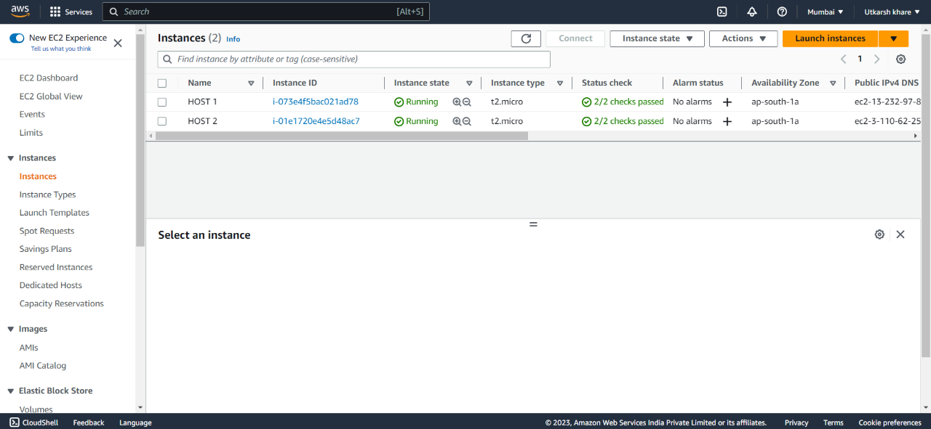

1. Go to security group and allowed http on port 80.
2. Open powershell and login to both virtual machine :-
3. “cd ./Downloads” (use “cd” to go to where private key is saved in your system which you used while creating instances)
4. “ssh -i ./key.pem ec2-user@public-ip-address”
5. Downloaded free webpage templates from “FREE CSS” website.
6. Use these commands to transfer webpage templates stored in system to instances :-
7. ‘sudo su’
8. “yum update -y”
9. “Yum install httpd -y” (To install apache server)
10. “ service httpd start ”
11. Open New terminal :-
12. “cd ./Downloads”
13. “scp -i /path/to/your/keypair.pem -r /path/to/css-templates ec2-user@public-ip-or-dns:/var/www/html/ ” (**scp** command to copy the entire CSS templates folder from your local system to the EC2 instance)

In my case:- scp -i .\key.pem -r C:\Users\Downloads\picstudio ec2user@Public_IPv4_DNS:/var/www/html

1. Came across an error “Premission Denied” to resolve this, used:-
2. “ sudo chown -R ec2-user:ec2-user /var/www/html/ ” (to change the ownership of the /var/www/html/ directory to the ec2-user)
3. “ sudo chmod -R 755 /var/www/html/ ” (To Change the permissions of the directory to allow write access)
4. Run point 5.b again and this time it was success!!
5. To check the template in instance:-
6. “ cd /var/www/html/ ”
7. “ls”
8. Now when you run the ip address you will see apache test page instead of your webpage, to resolve this:-
9. “sudo mv /etc/httpd/conf.d/welcome.conf /etc/httpd/conf.d/welcome.conf.bak” (Remove or rename the default Apache configuration file)
10. “sudo nano /etc/httpd/conf.d/my-website.conf” (Create a new virtual host configuration file for your website)
    * + - 1. Write this code in file created by point b.

<VirtualHost *:80>

ServerName example.com

DocumentRoot /var/www/html

<Directory /var/www/html>

Options Indexes FollowSymLinks MultiViews

AllowOverride All

Require all granted

</Directory>

</VirtualHost>

1. Restart the apache server:- “service httpd restart”
2. Run the public ip address or hostname :- <http://public-ip-or-dns/picstudio/>
3. Same procedure was done with HOST 2